DAYS GORILLAS &BIG FIVE (BWINDI IMPENETRABLE NATIONAL PARK AND KIDEPO VALLEY NATIONAL PARK)

A safari in Uganda is not complete without Bwindi Impenetrable Forest National Park and Kidepo Valley National Park these 2 parks are unique in the way that they harbor rear species which are found in them only in Uganda like Bwindi Impenetrable Forest National Park is known for Mountain Gorillas Kidepo Valley is with its welcoming savanna vegetation a Game drive in this park very rewarding with assured Cheetah amongst other destinations.

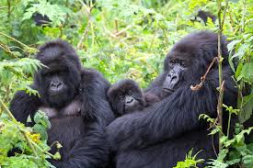

**DAY 1: ARRIVAL AT ENTEBBE INTERNATIONAL AIRPORT**

You will be welcomed by a representative of FRIENDS NATURE SAFARIS, Who will take you to your accommodation in Entebbe and rest, In case you arrived late, but if its in the morning we board a charter flight to Kisoro or Buhoma, And check in at our accommodation depending on the Gorilla Permits.

[DAY 2: BWINDI IMPENETRABLE FOREST NATIONAL PARK](http://www.friendsnaturesafaris.net)

In the morning we take our breakfast and assemble for briefing according to the group which we are going to trek/track about the does and donots.This activity is one of highlight of our safari, meeting with the gentle giants of Bwindi, Especially hikers will love the gorilla trekking in the beautiful ecosystem of the park. It is difficult to foresee how many hours you will hike, it may take two to eight hours. Expect to walk a long distance in steep and muddy conditions, sometimes with rain overhead, before you encounter any gorillas. But we found these creatures it is very rewarding and interesting as you observe them closely while they eat, play and rest. A unique and unforgettable experience! For conservation purposes, time spent with the gorillas is limited to one hour. The ranger guide always briefs you on how to behave with these giant apes. After the trek we return back to lodge for lunch and evening at leisure. Dinner and overnight at Silver Back Lodge Luxury (Any Equivalent).

**DAY 4: BWINDI IMPENETRABLE NATIONAL TO KIDEPO VALLEY NATIONAL PARK**

After morning breakfast, we fly towards the Northern part of the Country, Finally we arrive in Kidepo Valley National Park through LOKOMOTI gate.

**DAY 5: KIDEPO VALLEY NATIONAL PARK**

After a morning breakfast, Embark on our safari van and go for a Game Drive on the following trucks/Trails Boma, Kakeine,Buffalo,Nogosokopire, and expect to see animals like Cheetah,White Eared Kobs,Common Ostrich, Elands. In afternoon we visit LOLUKULO community to know more about their Social life, Economic life who are known for Cattle keeping. And after that we do a GAME DRIVE then go back to our lodge.

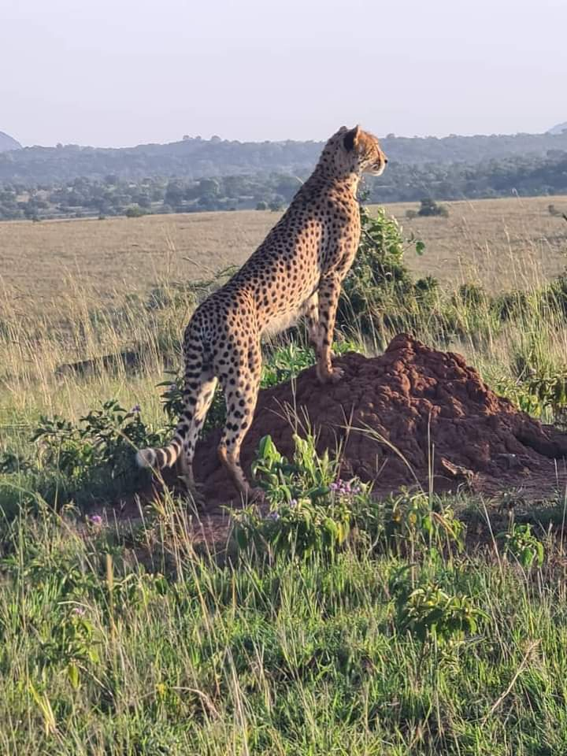

**DAY 6: KIDEPO VALLEY NATIONAL PARK TO ENTEBBE AIRPORT**

After morning breakfast we leave Kidepo Valley National to catch our flight to Entebbe International Airport,then transfer to our accommodation in Entebbe

**DAY 7: KAMPALA/ENTEBBE TO AIRPORT**

After breakfast depending on the time of your flight if its in the evening or at night we can do an Excursion during the day before going to the Airport back home.

